Link to pushed commit history on remote GitHub repository: Commits · Jon1oh/INF1103-Labs

Output of docker images command

Output of docker mount and run:
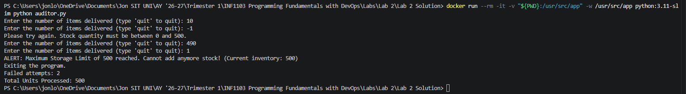

Showing the image can run while program is running and can accept and validate user input:
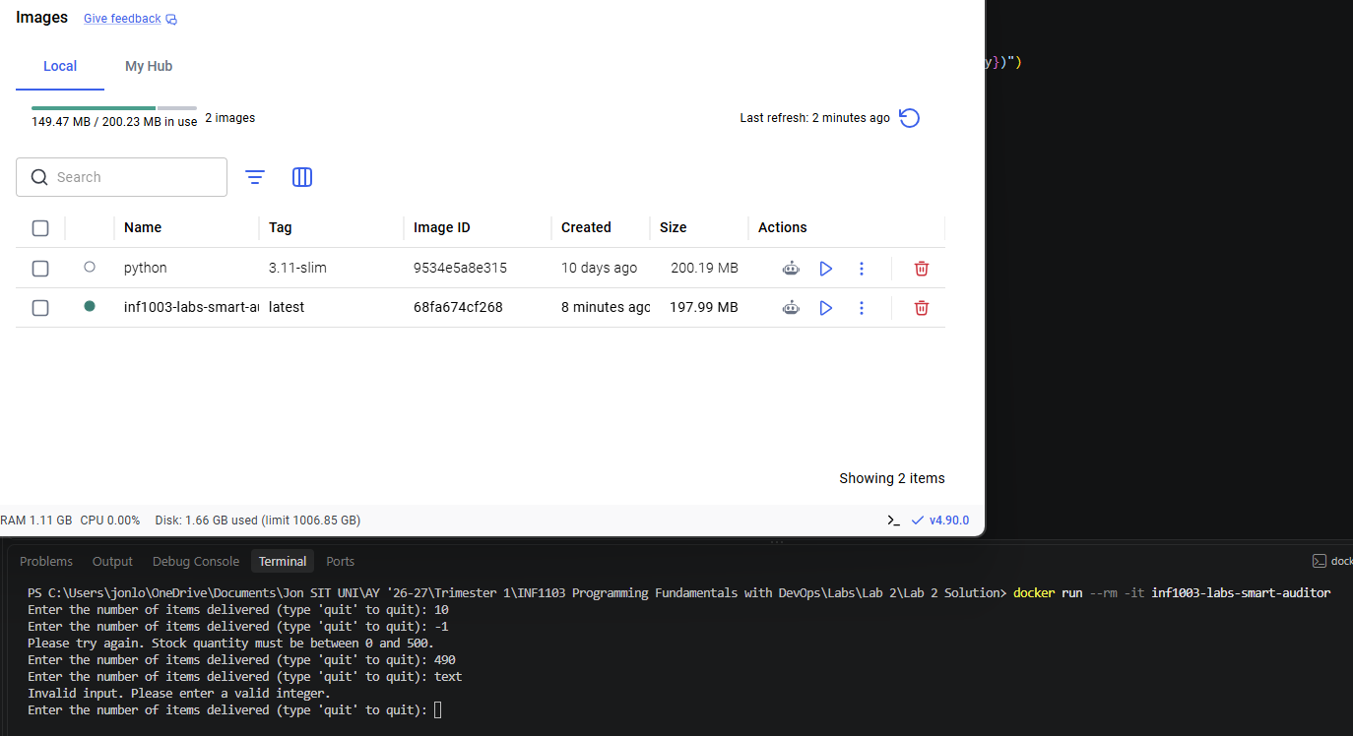

From the same running image in the previous screenshot, this screenshot shows the output when the user enters “quit” to exit the program.
